Name : Fariha Arai

AF ID : AF0443236

Lab 1

**Task 1. Installing Python on Windows**

To install Python on a Windows based computer, you can follow these general steps.

**Download Python:** Visit the official Python website at https://www.python.org/downloads/windows/ and download the latest Python installer for Windows. Choose the version that matches your system (e.g., 32-bit or 64-bit).

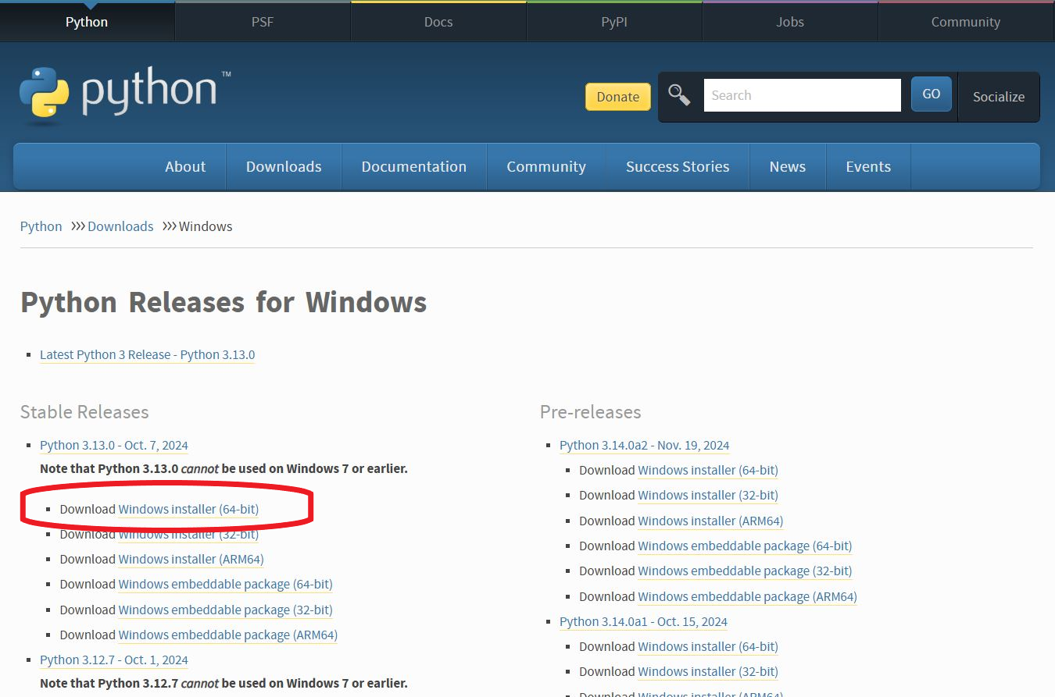

**Run the Installer:** Double-click the downloaded installer (e.g., python-3.x.x.exe) to run it. Make sure to check the box that says "Add Python X.X to PATH" during installation. This option is essential for using Python from the command line.

**Install Python:** Click "Install Now" to start the installation process. Python will be installed on your system.

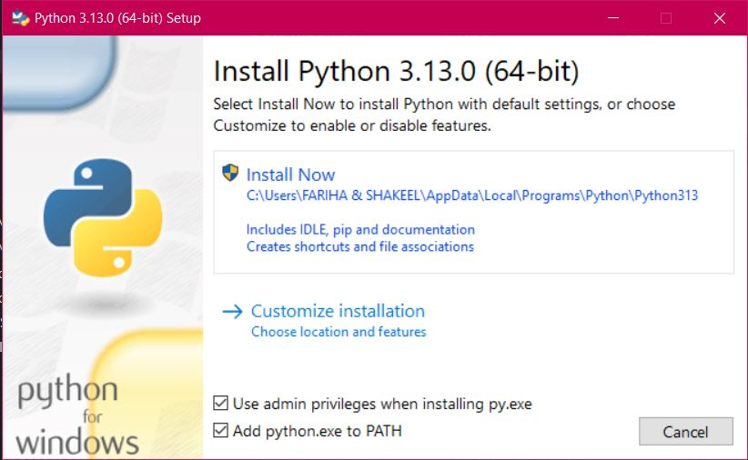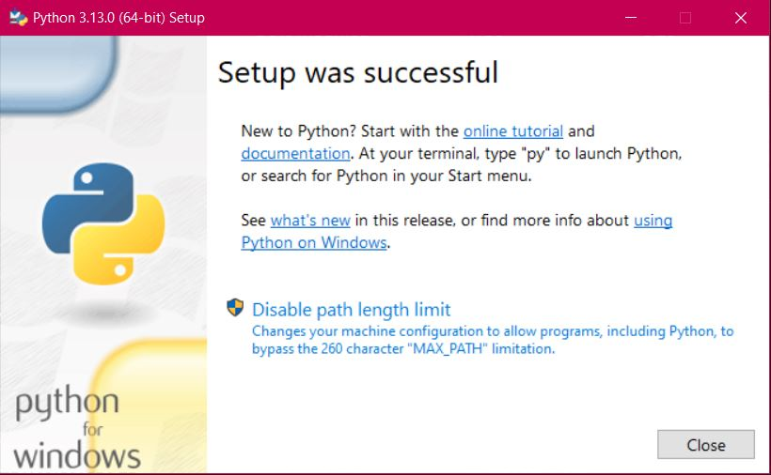

**Verify:** To verify that Python was installed correctly, open the Command Prompt (search for "cmd" in the Windows Start menu), and type python --version. You should see the installed Python version displayed.

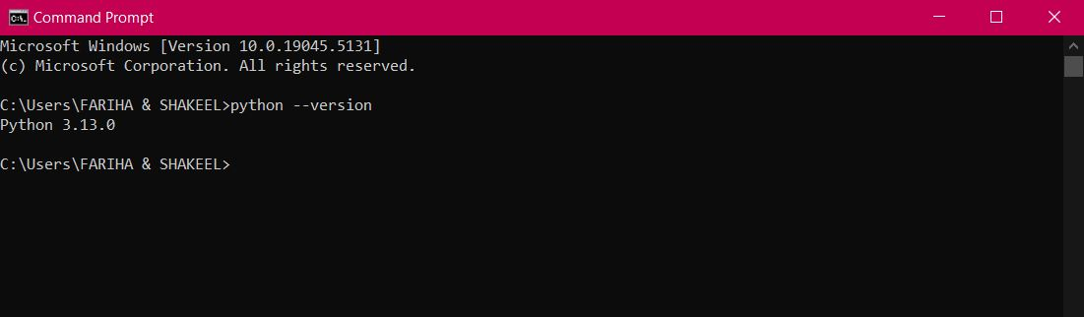

**Task 2. Demonstrate about Basics of Python Programming:**

Code:

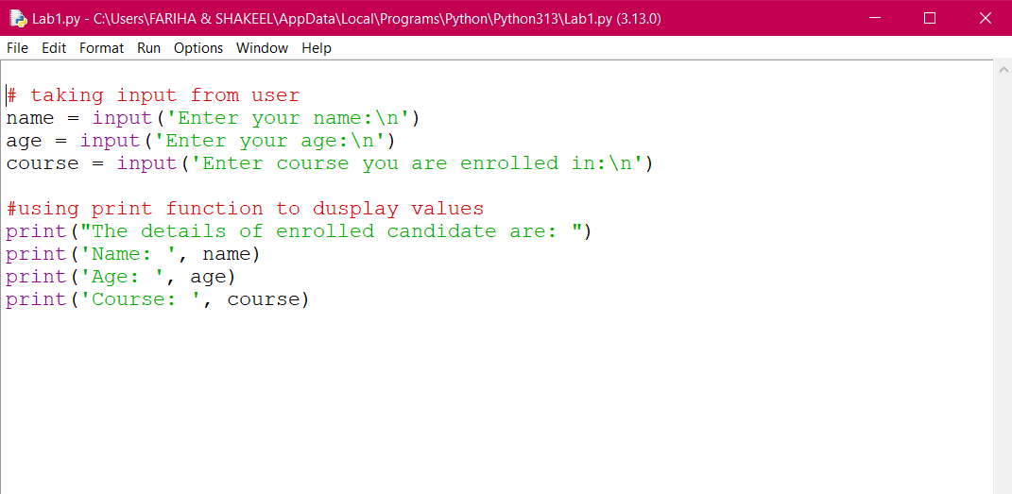

Output:

